**😊 AWS Transcribe**

**AWS Transcribe** is a fully managed automatic speech recognition (ASR) service offered by Amazon Web Services. It converts audio and video speech into text, making it easier to use spoken content in applications. AWS Transcribe is often used for tasks such as transcription of calls, interviews, meetings, videos, and any scenario where converting spoken words to text can provide value.

**Key Features:**

1. **Real-time Transcription**: Transcribe streaming audio in real-time, useful for applications like live captions or voice-enabled services.
2. **Batch Transcription**: Process pre-recorded audio and video files for transcription in bulk.
3. **Speaker Identification**: Identifies and labels multiple speakers in a conversation, ideal for meetings, customer service calls, or interviews.
4. **Custom Vocabulary**: Allows you to define specific words (like industry terms, product names, or acronyms) that may not be commonly recognized in general language models.
5. **Punctuation and Formatting**: Automatically adds punctuation, capitalization, and sentence formatting to transcribed text.
6. **Custom Language Models**: Provides customization of ASR models to improve accuracy in specific domains, such as finance or legal terminology.
7. **Language Support**: AWS Transcribe supports a wide range of languages, and AWS continuously adds new languages and dialects.
8. **Timestamps**: Assigns time stamps for each word in the transcription, making it easier to synchronize the text with the audio.
9. **Channel Identification**: Separates different channels in a multi-channel audio file (e.g., call center conversations between agents and customers).
10. **PII Redaction**: Automatically detects and redacts personally identifiable information (PII) from transcripts, useful for compliance with privacy regulations.
11. **Transcribe Medical**: A specialized version of AWS Transcribe for medical dictation, optimized for medical terminology and compliant with HIPAA standards.

**How It Works:**

* **Step 1**: Upload your audio or video file to Amazon S3 or stream it to AWS Transcribe.
* **Step 2**: AWS Transcribe processes the input, converting the speech to text.
* **Step 3**: The transcription results are stored in Amazon S3 or returned in real-time.

**Use Cases:**

* **Customer Service**: Transcribe call center conversations for quality assurance and agent performance tracking.
* **Media & Entertainment**: Captioning videos, podcasts, and broadcasts.
* **Healthcare**: Transcribe doctor-patient conversations for record-keeping and analysis.
* **Legal**: Transcribe depositions or court hearings.
* **Education**: Provide transcription for lectures, webinars, and online courses.

AWS Transcribe integrates with other AWS services like Amazon Comprehend for text analysis, Amazon Translate for translation, and Amazon Polly for text-to-speech conversion, making it a key component in building voice-enabled applications.

**😄 To begin with the Lab:**

1. In AWS Console, search for Amazon Transcribe and navigate to it. Now click on Create a transcribe.

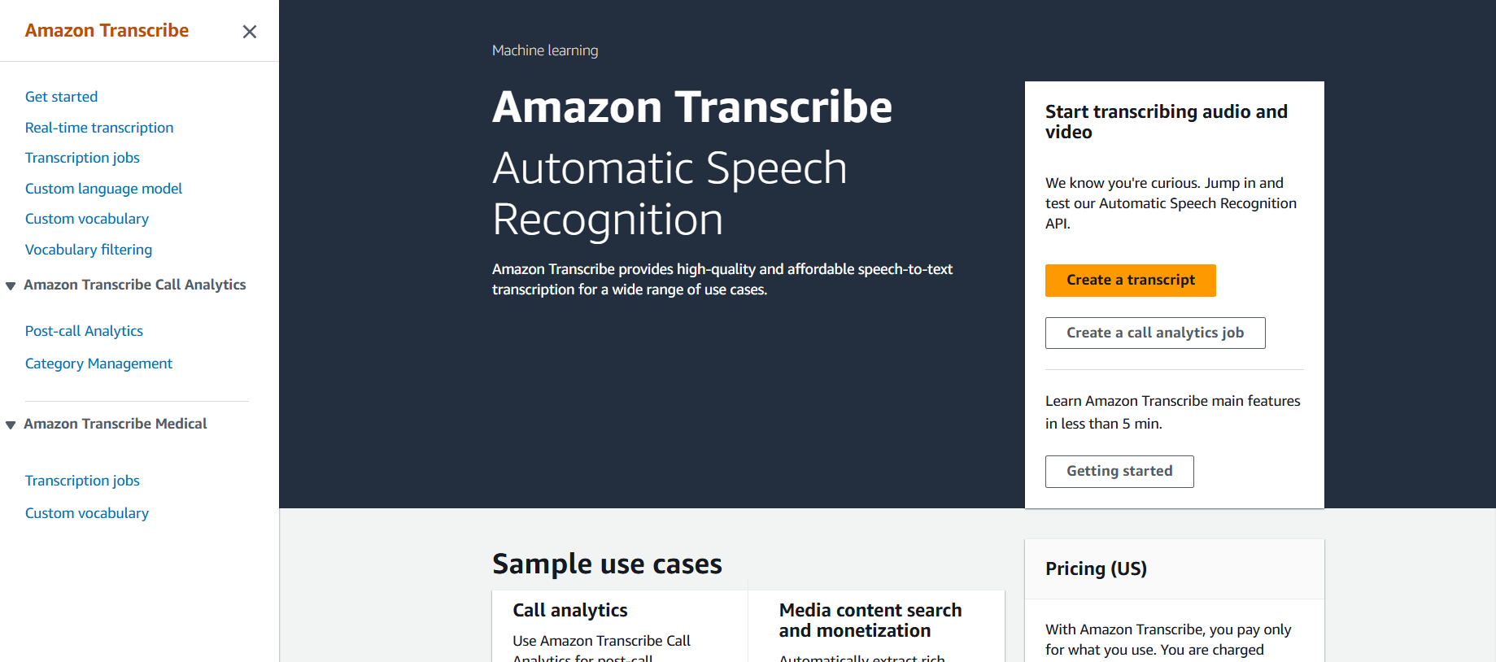

1. So, here you can do a real-time transcription of what you are saying. By clicking on start streaming and then speak.
2. Whatever you speak it will start transcription and you will see that in real time it is converting text for what you are speaking.

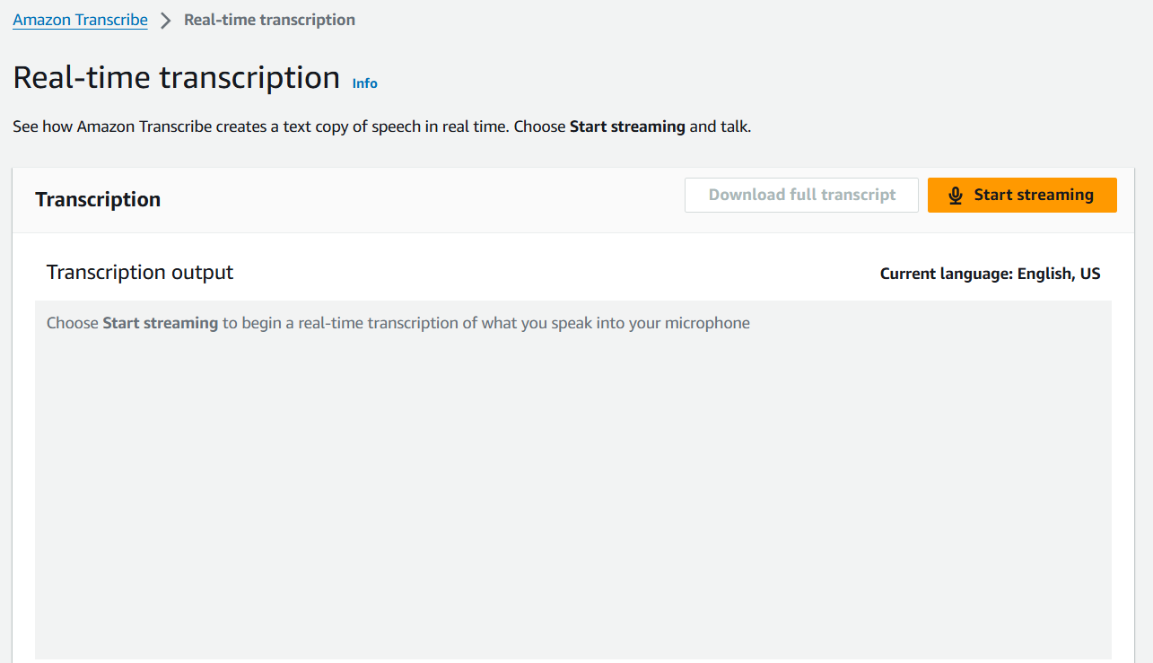

1. Now from the left pane some to transcription jobs and click on create job.

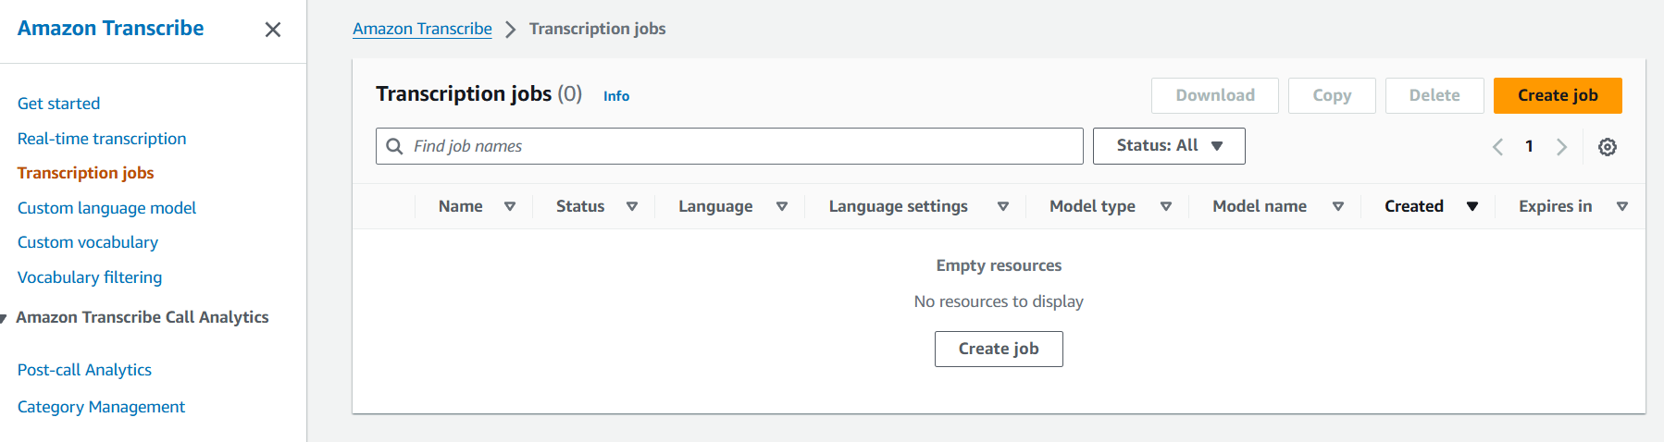

1. Here you can choose any specific language of your choice. Give a name to your Job.

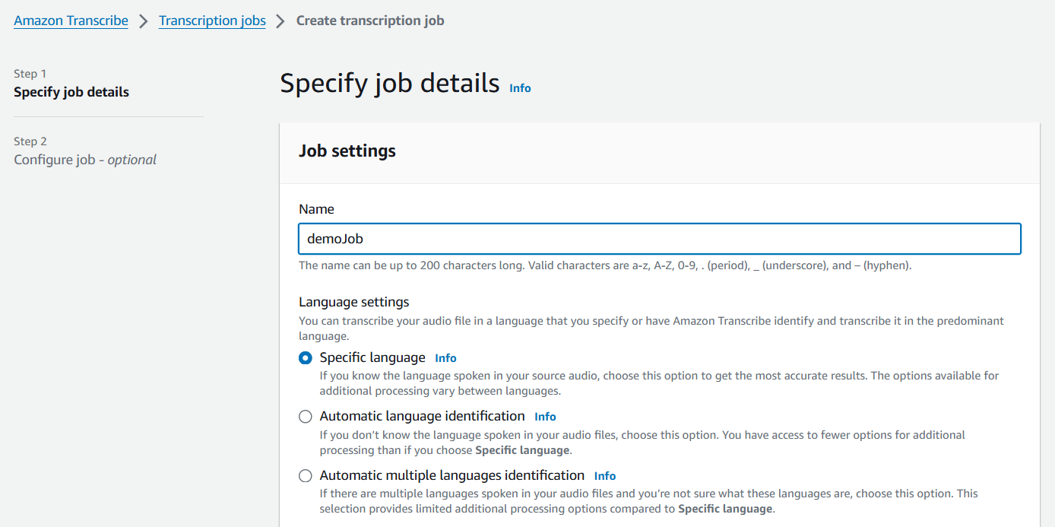

1. Choose model type as General model and you can also add job queue if you have multiple jobs.

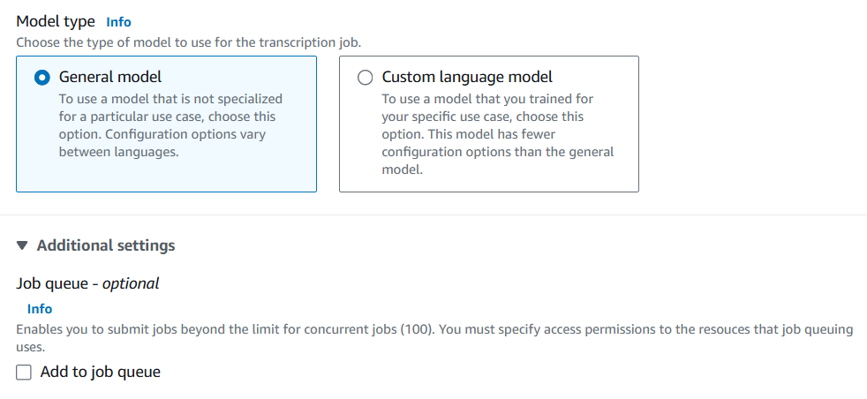

1. In the input data you need to provide the location of your object stored in S3 bucket.
2. So, go to S3 bucket create a bucket and then upload any audio or video of your choice then give the path of your object here as you can see below.

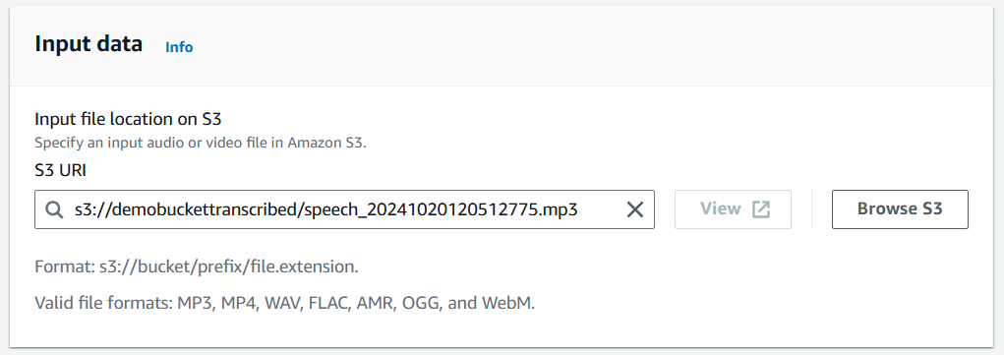

1. Now just create your job. Below you can see that the job is in progress.

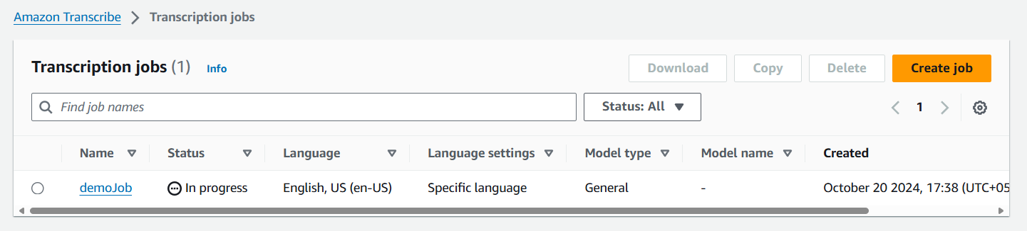

1. You can see that the status of you job has been changed to complete

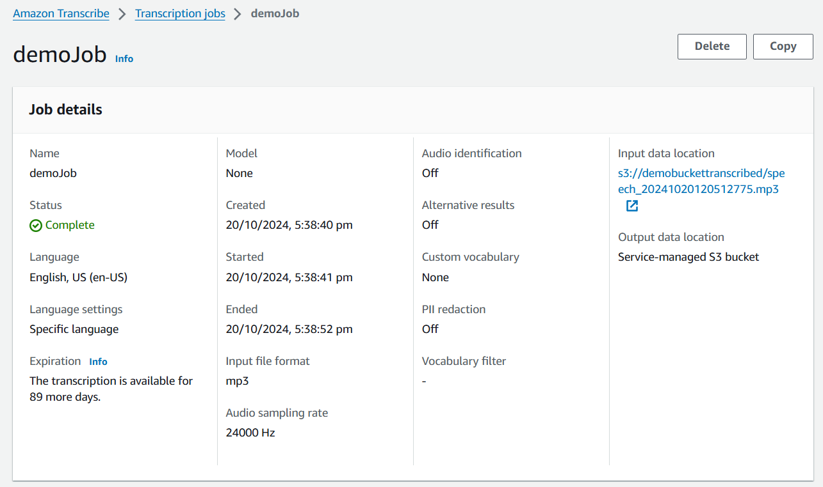

1. In the transcription preview you can read the text and compare it with the audio.

